**Solitude Station**

Isabella Black, Joshua Hudson, Phillip ‘Pip’ Peterson, Liam James, Callum Mabardi

**Quantum Motosoft**

Design Document

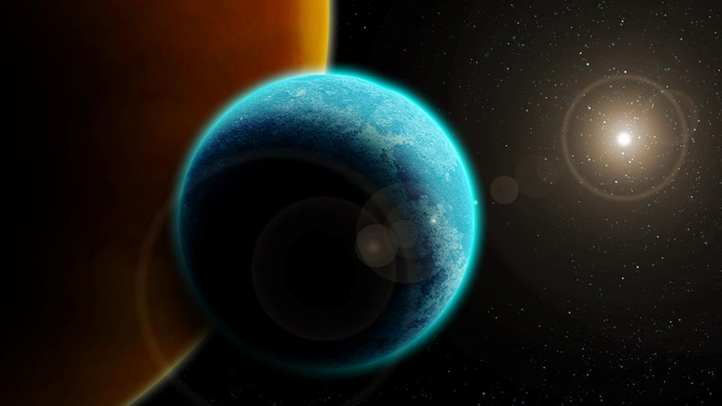

Contents

Intro 3

Target market 3

Platform 3

Type of play 3

Player behaviour 3

Character 5

Protagonist 5

AI 5

Enemies 5

Heavy drone 5

Cameras 5

Air sentry/flying drone 5

Rough Plot 6

Narrative 6

Embedded narrative elements 6

Gameplay 7

Experience 7

Mechanics 7

Grapple 7

Zero gravity 7

Level Design Objectives 8

Cut scene Description 8

Artistic style 9

Assets 12

Animation flow charts 12

Art Assets 12

Characters 12

Mechanic Assets 13

Text Assets 13

Sound Assets 14

Music and Foley work 14

Game flow 15

Proposed level 17

Game Controls 18

Game Interface 19

Project timeline 20

Team prospectus 21

Callum Mabardi 21

Isabella Black 21

Liam James 21

Joshua Hudson 21

Phillip Peterson 21

Additional ideas and possibilities 22

Scraped ideas 22

Future plans 22

Bibliography 23

Appendices 24

Game Screen Captures 24

Concept art 26

Character designs 26

Environments 29

Inspiration 30

# Intro

## Target market

The types of players that would be expected to play Solitude Station are both males and females between the ages 18 to 35. This is not to say that people not in this age group could not both play and enjoy the game. This is simply the largest demographic. Core gamers or people who play a large amount of time are also included in our target market. Casual players would arguably not enjoy the genre or type of Gameplay employed din solitude station. As it is a more mature gamer playing Solitude Station the ‘types’ of players are conquerors and wanders. Conquerors wold be the ideal type of player as their need to complete or ‘beat’ the game would encourage them to continue playing. Their intrinsic need to win.

## Platform

Solitude Station is a PC title with controller compatibility. As a pc platform this game will be wildly available to a larger source of people and the two different types of play again draws in a larger audience.

Type of play

Agon is the type of play that solitude station will primary employ. Single Vs many being the primary concept. As a lone survivor on a space station the player is required to face then many different types of enemies. This entails hard competition encouraging the player to succeed. As this game is a thriller with a very difficult win condition and play style the payoff for this difficulty is the concept of *Fiero. Fiero* being emotion pay off through triumph or winning. If this isn’t enough it will also be through the acquisition of new toys and rich narrative embedded into the level. Solitude station will also play very heavily on the fight vs flight mechanic. As there is no combat it will be focused on flight exclusively.

Player behaviour

The player behaviour in solitude station is primarily driven by victory rewards and narrative rewards. Players defeating levels or particularly hard enemies will be a purely agonistic reward appealing to conqueror players. With narrative rewards like cut scenes and dialogue which will be very effective for wanderer players. The secondary rewards and player incentives will consist of new toys. These new toys being the grapple hook and jet pack. The second being new places, which like new toys introduces new places for players to explore both of these rewards are highly effective for wanderer players.

Another way players will be rewarded is rewarding though the completion of puzzles and levels as the difficulty increases, otherwise the player will be egged on from their deaths and failures. However if the player does not master skills and mechanics quickly or effectively the may be met with negative reinforcement, for when a player dies they are taken back to a checkpoint. The winning of small puzzles and fun aspects of zero gravity will balance out the harsh reality of an easy loss. The primary motivation other than rewards will be immersive narrative game flow and self-determination.

Motivation will be a balance between story and self-motivation as the difficulty of the game will increase largely in later levels it is up to the player to continue in the effort to complete.

Character Bios

## Protagonist

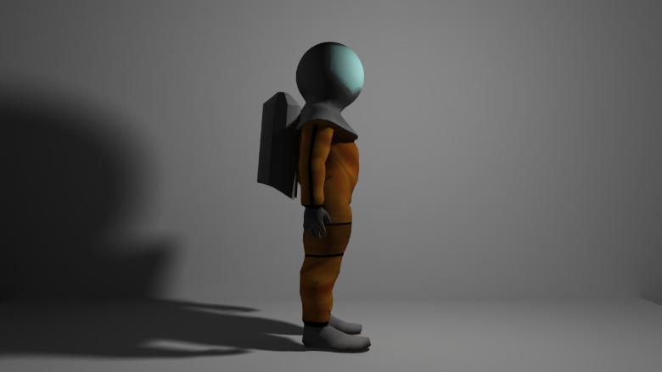Waking up on a damaged and abandoned space station in deep space the protagonist is unaware of who they are or what has happened to the station. Not much is known about the protagonist except they were an engineer/scientist on solitude station, a research ship orbiting titan.

The player never sees the protagonist as they wear their space suit at all times during the story. This is used both as a narrative device and because the ship is damaged in certain areas means the protagonist wouldn’t be able to breath.

## AI

The AI who was in control of the stations automated systems and drone management, has been removed from the network and has contacted the protagonist in order to reconnect to the station and get the situation under control. The Ai companion will act as a guardian for the protagonist when they reach terminals throughout the ship. Explaining things to the character and helping them through levels.

## Enemies

As Solitude Station is a research facility most of the enemies are research drones that have gone haywire. They are designed for research and exploration purposes and therefore aren’t loaded up with military weapons.

## Heavy drone

A spider like drone designed for exploration purposes on the moon’s surface. Six legged and about the size of a horse this drone will launch itself at the character, if it spots them, crushing the player to death.

## Cameras

Mounted on walls, security drones will monitor whatever is going on around them. On an axis and swings back and forth, if a camera spots the character it will exterminate the character immediately. They have a precise cone of vison and a set path making avoiding them possible. More often than not a character can turn a camera on or off if the can locate the power switch/board.

Cameras are often located in or around doorways. Mounted from good vantage points on walls, players will need to watch for their cone of vision and avoid it, if they wish to get past alive.

## Air sentry/flying drone

A disk shaped floating reconnaissance drone deployed by the ship for external repairs etc. It has a small cutting laser that is more than enough to kill the player should it see them. Will usually monitor large rooms and vents in and around the station.

# Rough Plot

## Narrative

The player wakes up in an abandoned station, they are alone and the power is off. Already inside an EVA suit, they then proceed through a few rooms, everything has been left seemingly without any struggle, no bodies no damage nothing supernatural, but there is no power in these rooms. Upon entering one room, they notice a single terminal still has power. They interact with the terminal and the receive text communication from the stations control AI, they are informed that the AI has been disconnected from the network it uses to control the automated systems on the station. It then tasks the player with several things, restoring full power to the whole station, reconnecting the long distance communication array and finally getting to the bridge to send a signal back to earth.

The research team are doing the preliminary tests to see if titan is viable for terraforming, but while looking into the Kraken Mare (the largest ocean on titan) they find a gigantic structure that appears to be some kind of tomb. It is radiating some kind of wave form never before seen in this plane of reality. Upon discovering this, they communicate with the control team back on earth and re-purpose the station to research what is held within the structure. Over the course of the research one member of the small team of scientists begins to have strange repeating dreams, they begin to go insane and eventually go down to the planet and releases what was in the tomb. The thing inside the tomb is being of pure energy from another dimension that wipes out all organic life in the galaxy. As you, the player, are not a human and in fact a cyborg, you survive with no memory of what happened or knowledge that all organic life has been erased. The final scene is you and the AI attempting to contact earth only to discover everyone has vanished.

## Embedded narrative elements

Narrative throughout the level will be conveyed to the player through the AI companion. This forced narrative will tell the player enough to understand the general concepts of the narrative and story elements. Why the station is damaged and that the player must try and escape back to earth. It will be up to the player whether or not they choose to search for the embedded narrative scattered around the level. Embedded narrative will expand upon the initial and basic forced narrative; fleshing out the details of titan and information about the protagonist. This will be very important in drawing in wander players and those who enjoy/value rich narrative in games. It will also help build the atmosphere.

# 

# Gameplay

## Experience

The gameplay experience for Solitude Station is tense platformer relying heavily on the feeling of isolation and solitude. This experience will be created and rely heavily on audio and visual cues to build tension for the player. This tension built through ambient Foley work and a distinct visual aesthetic will also aid in this process. 80’s sinister synth for sections with music as it suits the look and feel of the game. However music will be limited to sections that need more pressure during gameplay as it will add immersion and match the experience. The player’s isolation as the only person on the space station is the basis for the isolating game experience. This is compounded by the limited and scarce contact they have with the AI guiding partner.

## Mechanics

### Grapple

The primary mechanic within solitude station is the grapple hook. The grapple hook is presented to the player early in the game and functions as it would in real life. The grapple can attach to most things in the game, primarily walls, objects and platforms. Here are limits on how far the grapple can extend again making it more realistic. The grapple is able to either retract pulling the player up depending on what they are attached to or pull items like crates and canisters towards the player.

### Zero gravity

Zero gravity is the second main mechanic in Solitude Station and functions as realistically as possible in an effort to keep the player immersed. Whilst in zero gravity the player will float around in whatever direction they were initially travelling in. the grapple hook can be used to move towards whatever wall/object the player grapples to.

# Level Design Objectives

The design objectives we have for this game are to have challenging gameplay but not so punishing that players do not stop playing. To create unique mechanics and narrative elements to set Solitude Station from other sci-fi space setting games. The design objectives for Solitude Station is for a grunge, dark and foreboding art style. This will be created and conveyed throughout he dark and monotonous textures and environment art as well as the lights within the level. Please see the appendices for screen captures of gameplay too see how these elements tie together and are demonstrated.

## Cut scene Description

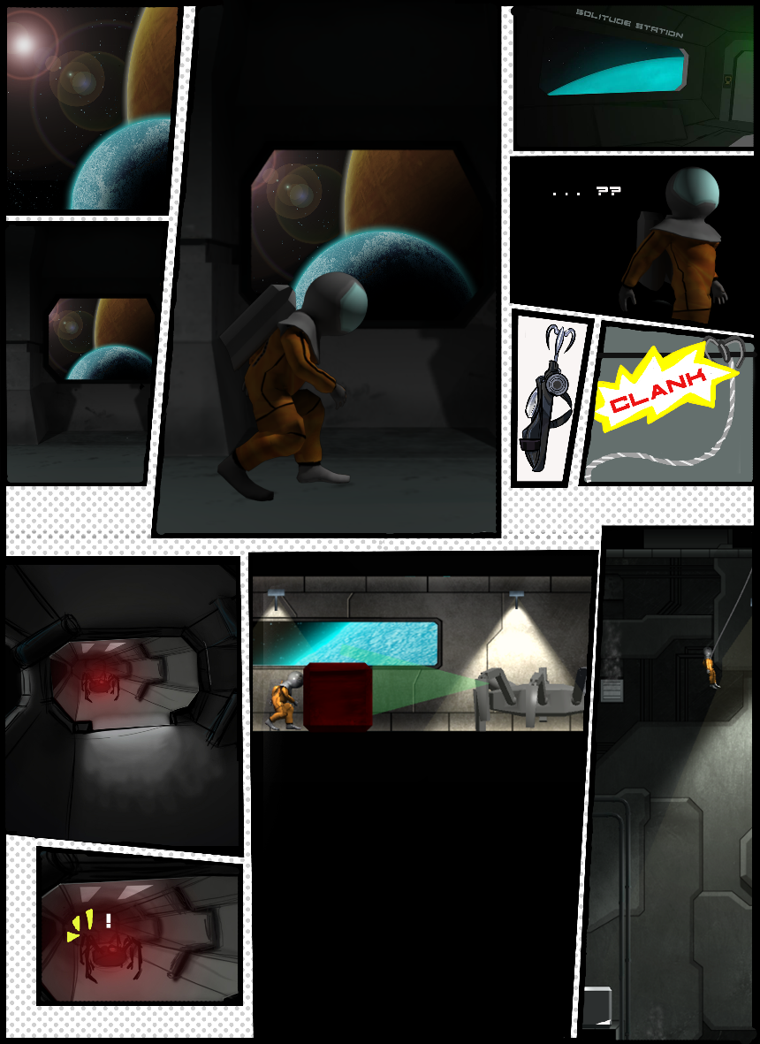The cut scenes of the game will be dynamic graphic novel style animations that will look much like the image here. This was chosen it accurately represents the style and artists preference we are choosing to show in the game. It will enable us to show an in-depth narrative whilst keeping the delivery simplistic.

# Artistic style

Final character turn around

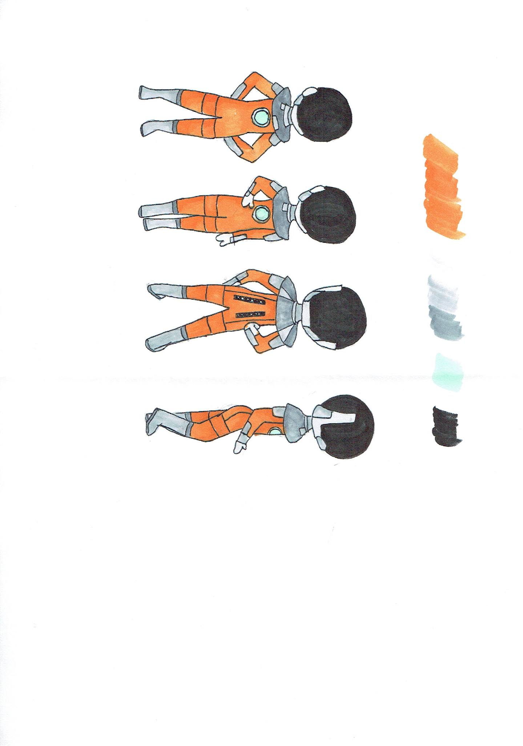

Final Character UV map

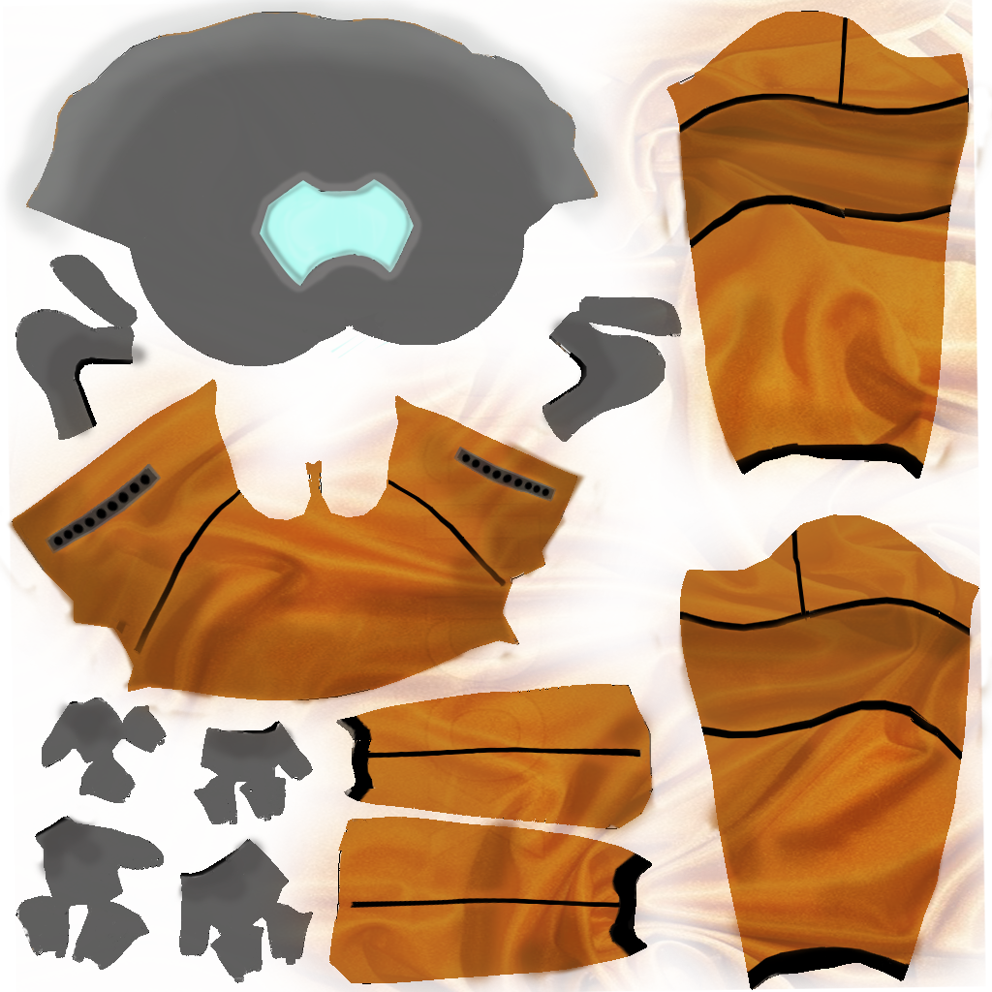

Final character render

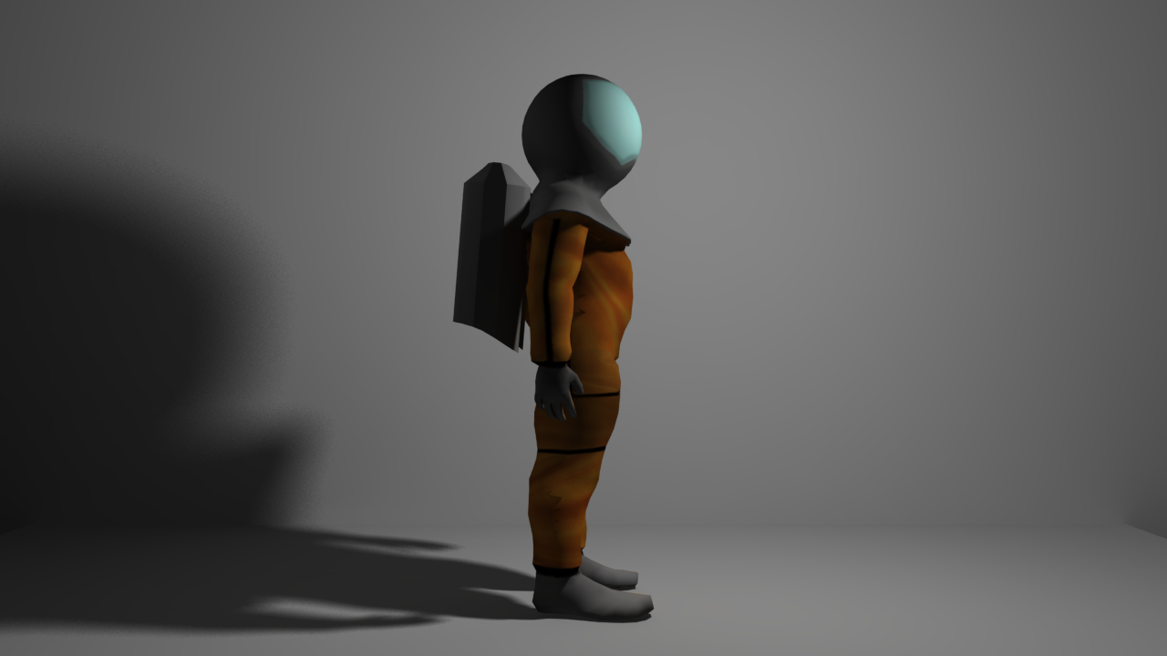

The art style of Solitude Station is a mix of 3d and cell shading which creates a unique and individual look. 3D models of the environment are both new and representative of the new art direction we will be taking. It helps encapsulate feelings of isolation and solitude and enable us to have far more depth in the environments than we did previously with 2D textures. All of our art is purposefully dark and sombre this is to emulate the feelings of loneliness, solitude and isolation that our gameplay and narrative creates. The monotonous colour schemes were chosen to aid in the alienation of the player. With colours only being added if it was important. Like the main character being orange. The player’s eye is drawn to it as it is the brightest thing in the scene, this also applies to objects like switches and terminals.

Above are the final turn around, texture map and render of the character. As little is known about the protagonist the design was kept simple on purpose. For more examples of the art in solitude station please see the appendices.

Alternerate colour schemes and outfits for character.

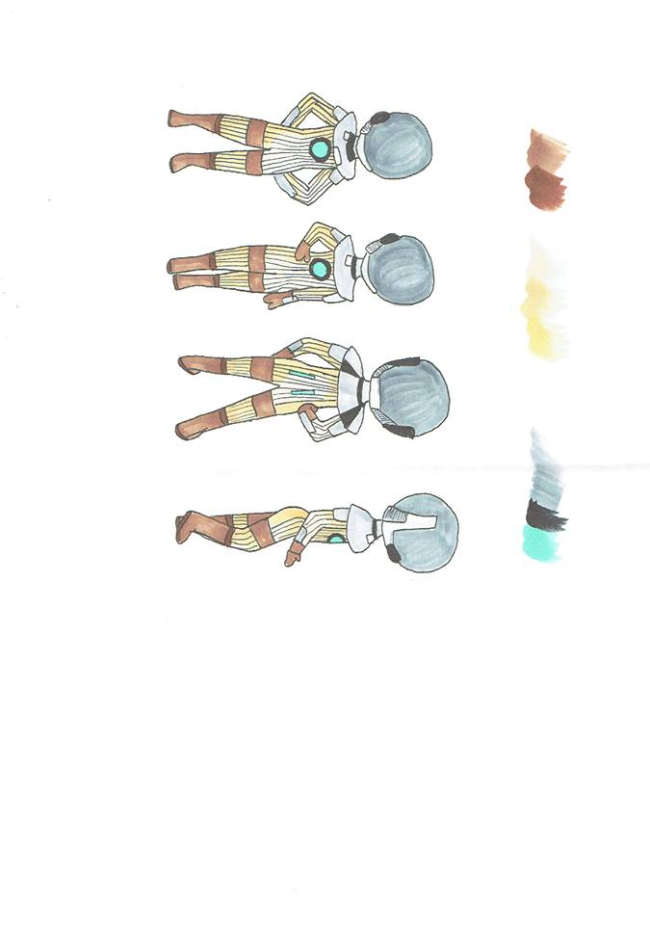

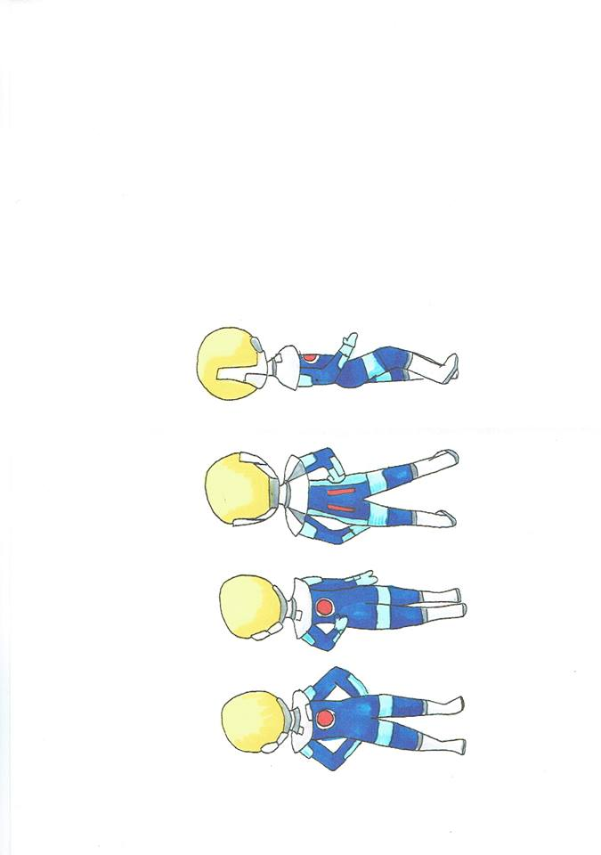

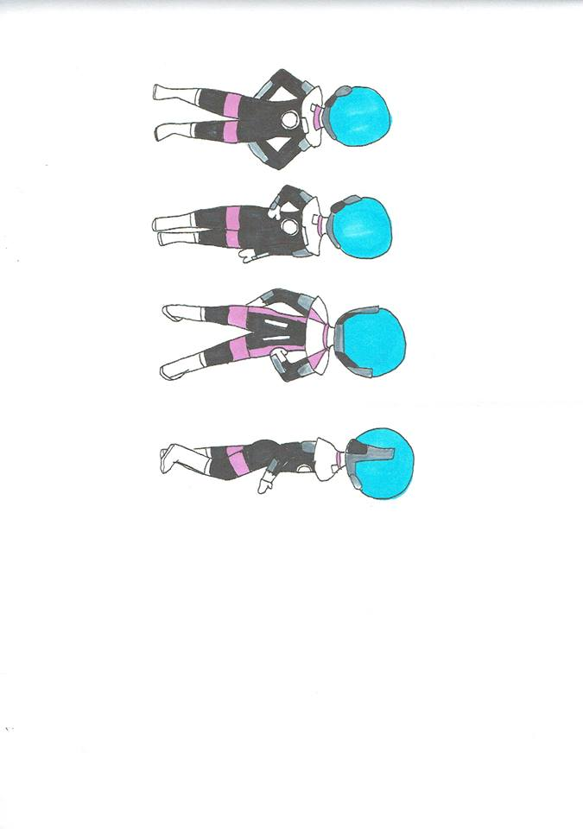

# Assets

## Animation flow charts

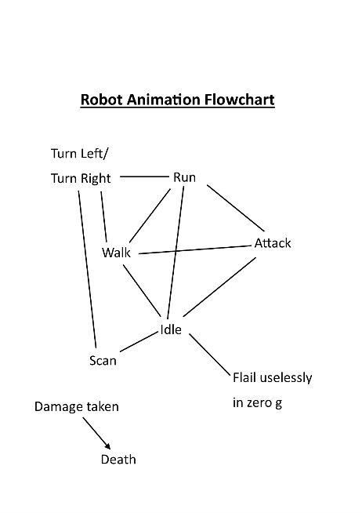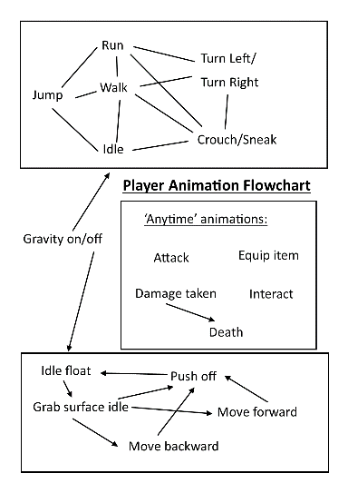

## Art Assets

* box/crates
  + various sizes
  + damaged/undamaged
* pipes
* lights (SPRITES)
  + down lights
  + wall mounted cover lamps
* doors
* grappling hook

### Characters

* Protagonist
  + separate arm animation due to grappling hook and axis
* Robots (enemies)
  + Heavy Drone (large)
  + Security Camera
  + Air Sentry

## Mechanic Assets

* General character movement
* Character gravity transition
* Gravity zones
* Cache checkpoints
* Character/box interaction
* Character RCS in zero gravity
* Box physics in multiple gravity
* Box/gravity transition
* Enemy movement in 1G
* Enemy gravity transition
* Grapple spawning
* Tether spawn
* Grapple-player interaction
  + Multiple gravity
* Grapple object interaction
* Grapple ascension / dissention

## Text Assets

* AI communication on screen (when not talking)
* Logs (collectibles)
* Emergent narrative art (on walls, in terminals, art)

## Sound Assets

### Music and Foley work

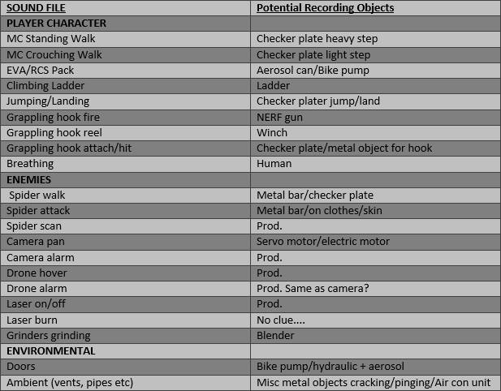

The music choice for solitude station is dark and ominous 80’s synth. The reason this was chosen is because it suits the isolated feeling that we wish to project when the player is playing the game. Music will be limited throughout the game, with it only playing in cut scenes and moments that we be lacking. This is because we wish the player to be immersed in the solitude and crate an isolating gameplay experience. The music is integral to creating the right feeling within the game.

# Game flow

The game flow within Solitude station will increase over time with various tasks. The table above is the game flow within the initial/first level of the game. Staring with the tutorial section the player will be shown and encouraged to move around the initial room, both familiarising them with the controls and what the levels looks and feels like. After this the player will encounter an enemy for the first time within a controlled environment so they cannot die. This first sighting/interaction with the enemy will begin the increase of tensions that will increase over the remainder of the level. After the player has recovered from dealing with their first encounter of dealing with an enemy they will be thrown into the narrative, which will take away any remaining tension.

After these three things the player will be ready to face and re encounter these three things throughout the level. Starting with the introduction of enemies more frequently in the environment. This will mean stealthing and avoidance of enemies until the conflict and tension peaks and the payer feels the satisfaction of completing a task or winning an area. This will be followed by the second narrative section. The narrative section will build upon what has been learnt and encountered previously. Now that the player has a confident grasp on how platforming and exploring the level works along with a decent grasp on the actual background and story behind the level, the major mechanic can now be introduced. The grapple hook being an integral part of gameplay and player experience is introduced midway to build tension for the player both through the mastery of this mechanic and the added stress of getting it right. The platforming sections will increase in difficulty to increase the mastery of the grapple hook and to keep the environment new and interesting to the player. The tension will then apex again with the inclusion of enemies wining the platforming and grapple sections until the player then clears that section.

The third narrative section will release tensions before throwing the player straight back in. it will give them a more detailed background and immersive information. And be a reward for what they have just completed in the previous section. To finalise the level the tension will then be exponentially increased by combining all that has been learnt by the player previously and making hem use all skills to the beat that part of the level. Meaning the grapple hook will need to be used proficiently to platform difficult sections while avoiding dangerous enemies. The player will then complete the level and be rewarded with a cut scene and valuable narrative and game information.

# D:\New folder\LevelTemp.pngProposed level

Above is the propsed first level for soitude station. It is projceted to play through between 30 and 45 minuets. This level will enabe the player to begin mastery of the main mechanics; grapple hook, zero grabity and stealth. The leveel begins in a controled enviroment enabling the player to become comfortable. For a complete breakdown of how this level will flow and play please see the Game Flow section and Gameplay experience.

# Game Controls

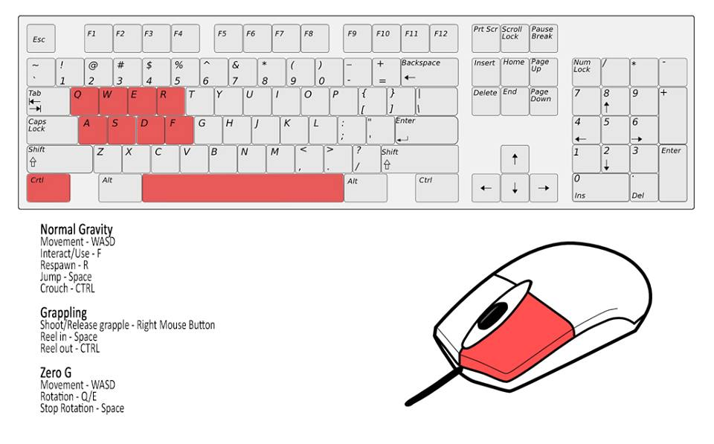

Above are the game controls, in an effort to make playing the game easier the key mechanics and their buttons were attempted to be kept closer together. As the game develops over the course of this year these controls may be subject to change in favour of useability of play.

# Game Interface

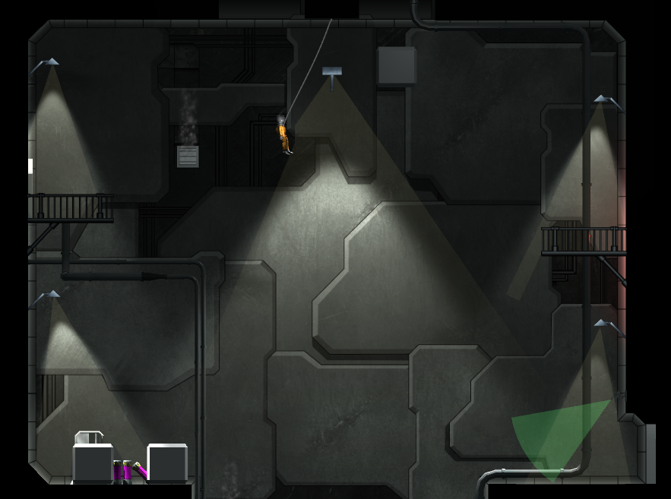There is no game interface in Solitude Station, or GUI. This decision was made on purpose as there is no combat in the game, or health bars there is nothing that needs to be displayed. As seen in the screen captures below there is nothing displayed on screen except what is going on in the level.

Anything that needs to be communicated to the player is done through visual cues on screen, like the colour of lights and flickering. Like the cameras light being green; indicating that it is on and can detect players.

# Project timeline

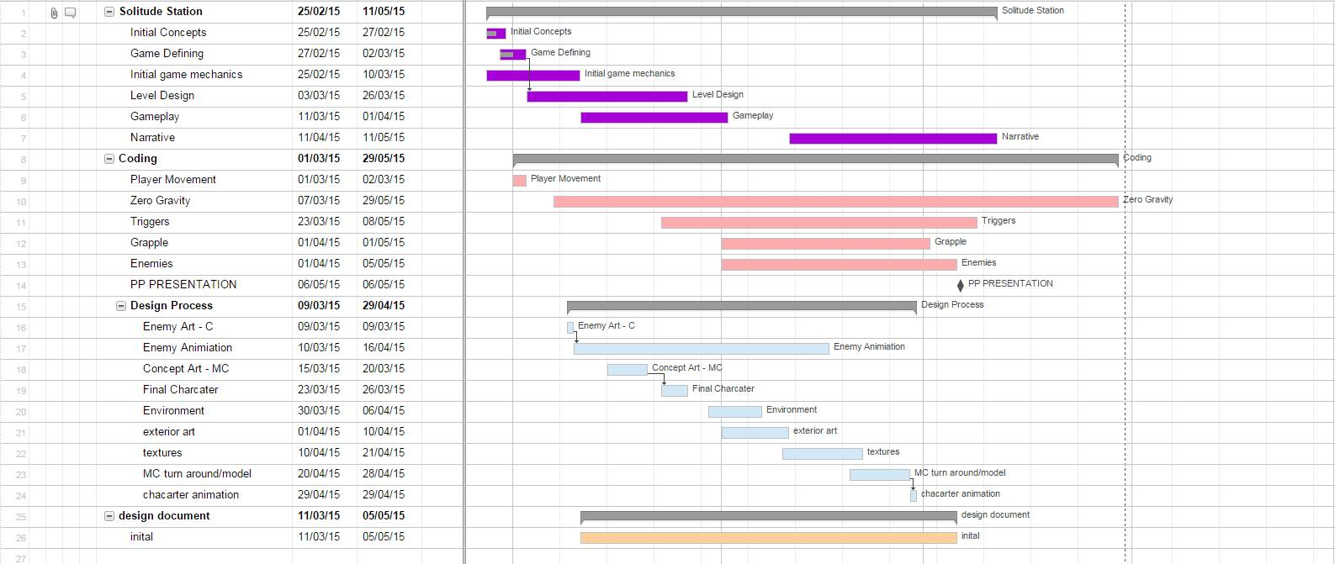

# Team prospectus

## Callum Mabardi

* Team lead
* Artist
* Design and Game building

## Isabella Black

* Artist
* Textures
* Organisation
* Design

## Liam James

* Level build
* Mechanic and animation implementation

## Joshua Hudson

* Lead programmer

## Phillip Peterson

* Animation
* 3D modeller
* Artist

# Additional ideas and possibilities

## Scraped ideas

* Emotional heavy characters
* Cliché horror tropes i.e. jump scares

## Future plans

* Character being able to mantle onto platforms. If a player cannot grapple or misses a platform and is close enough to a platform they can mantle onto it instead of falling. The code for this mechanic does work but is missing an animation so it cannot be implemented into the game/prototype as of yet.
* 3D modelled environment art as it suits the feel of the game better.

# Bibliography

Alientrap. (n.d.). Capsized. *2014*.

LTd, D. (2014, august 13). Dex. *Dex: The Game*.

# Appendices

## Game Screen Captures

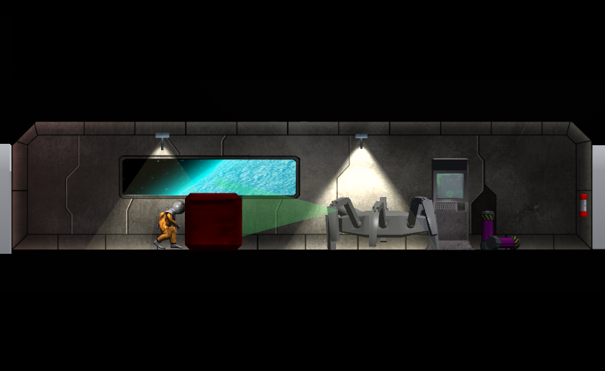

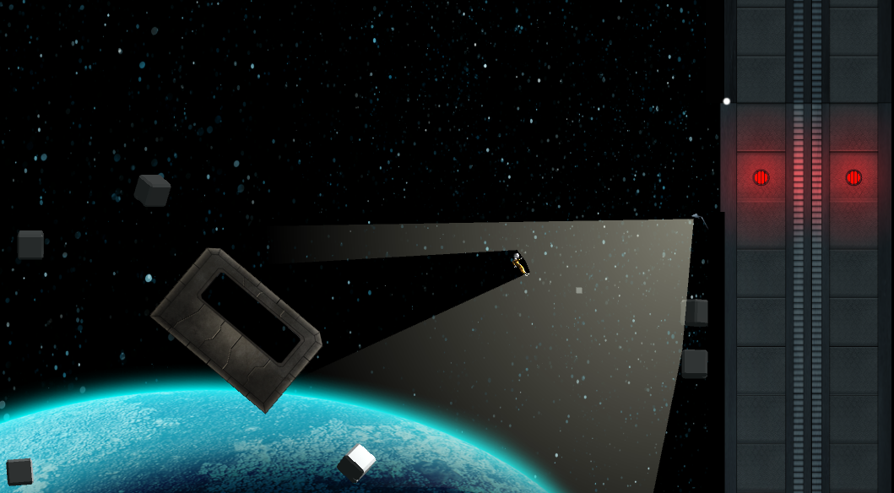

## Concept art

### Character designs

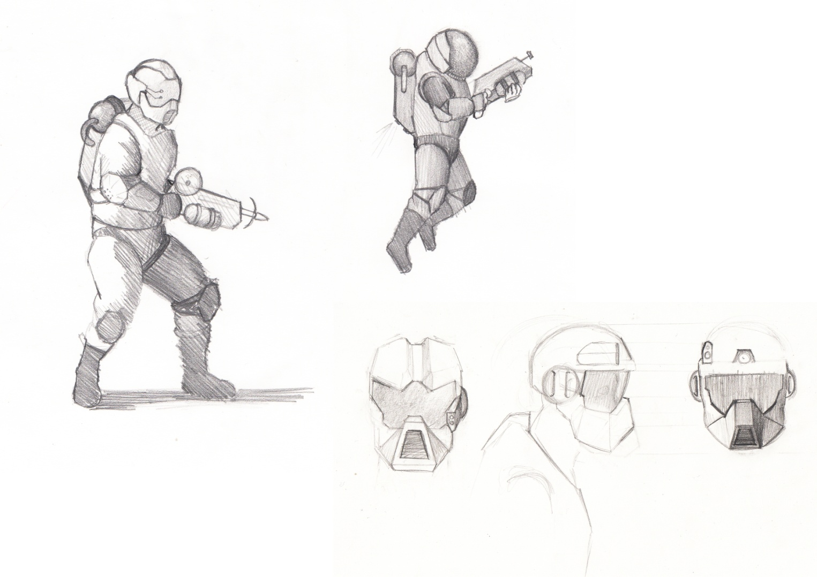

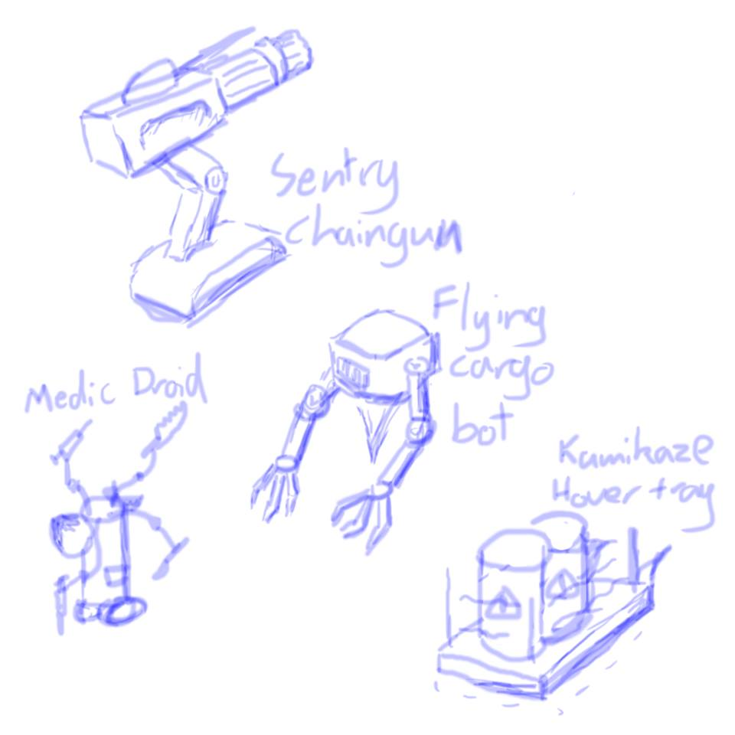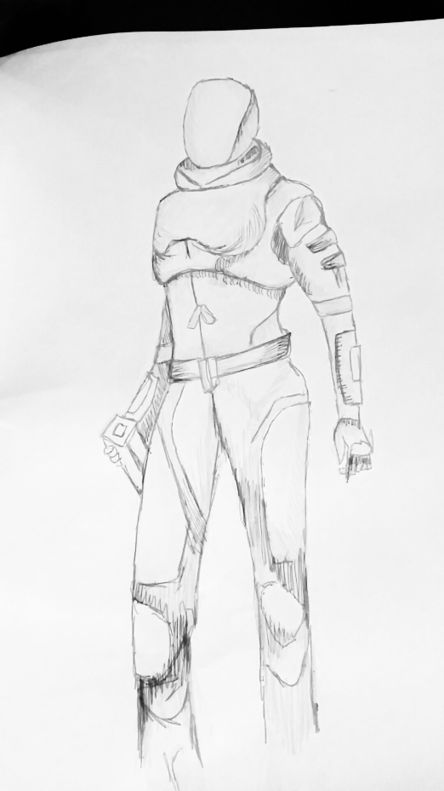

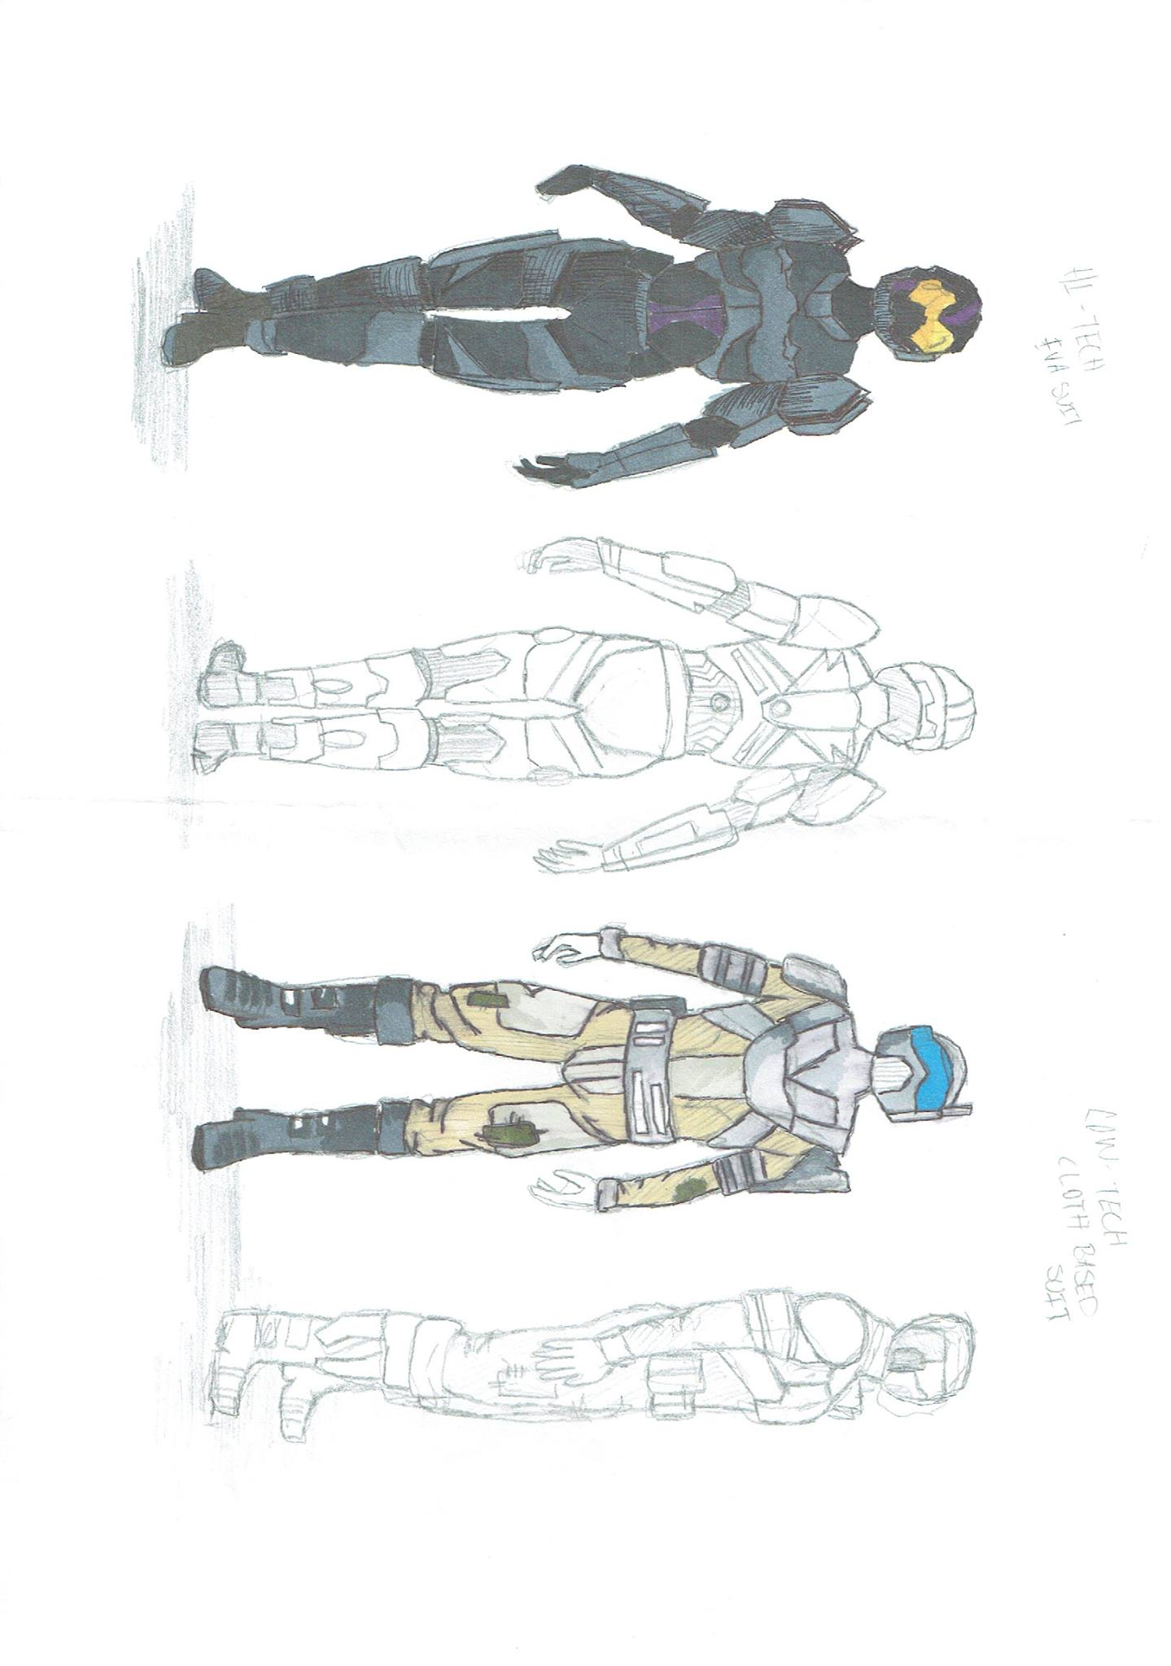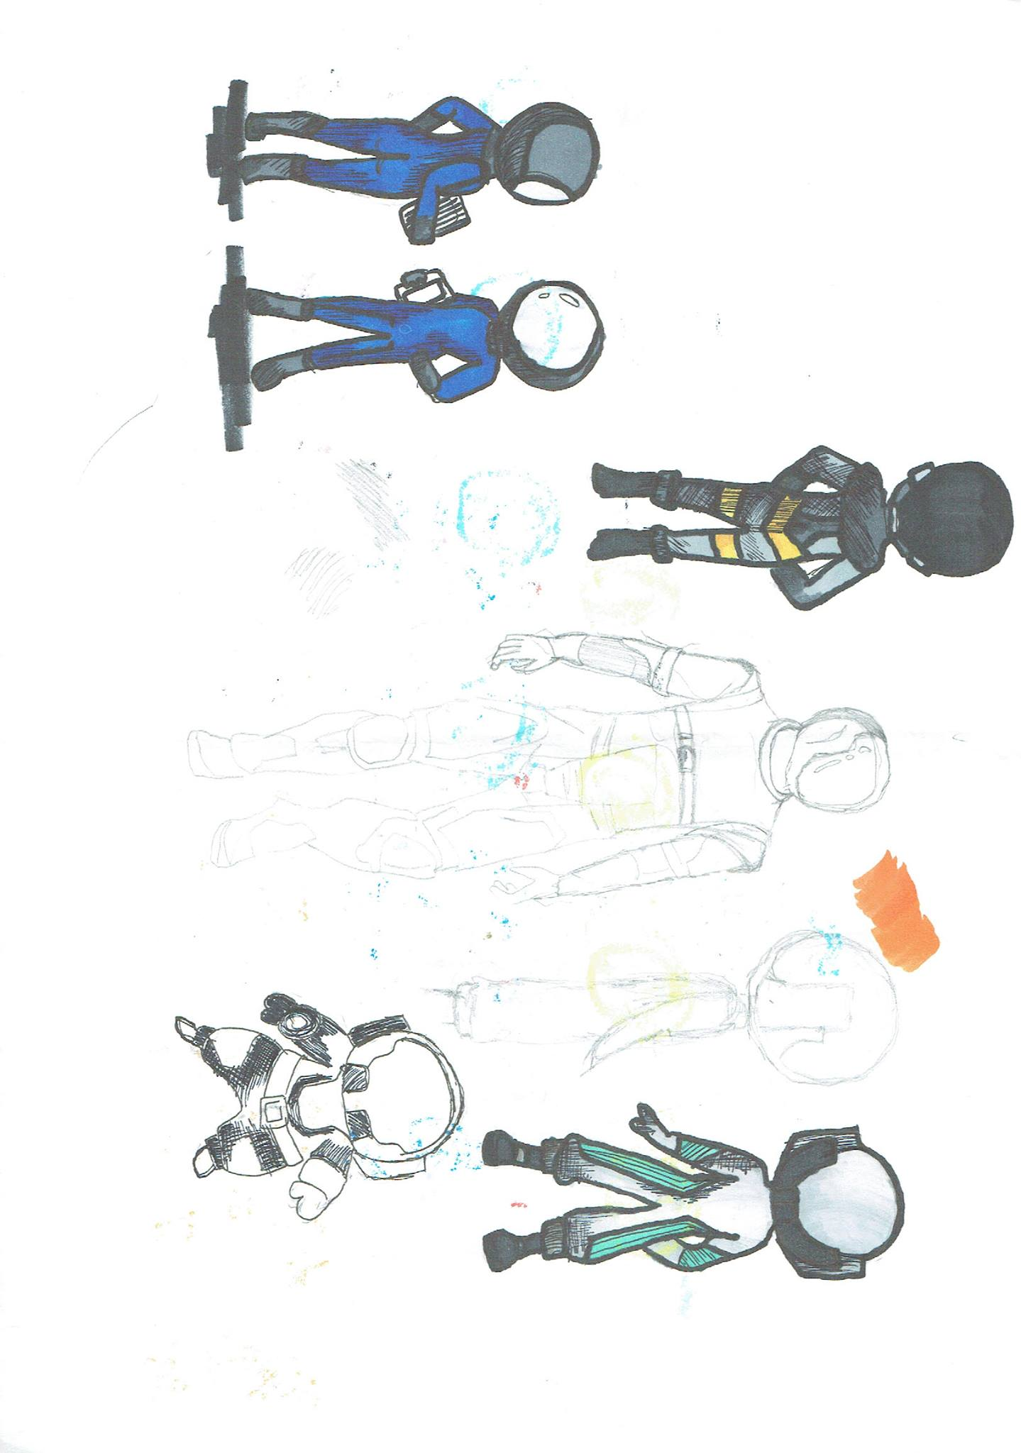

### Environments

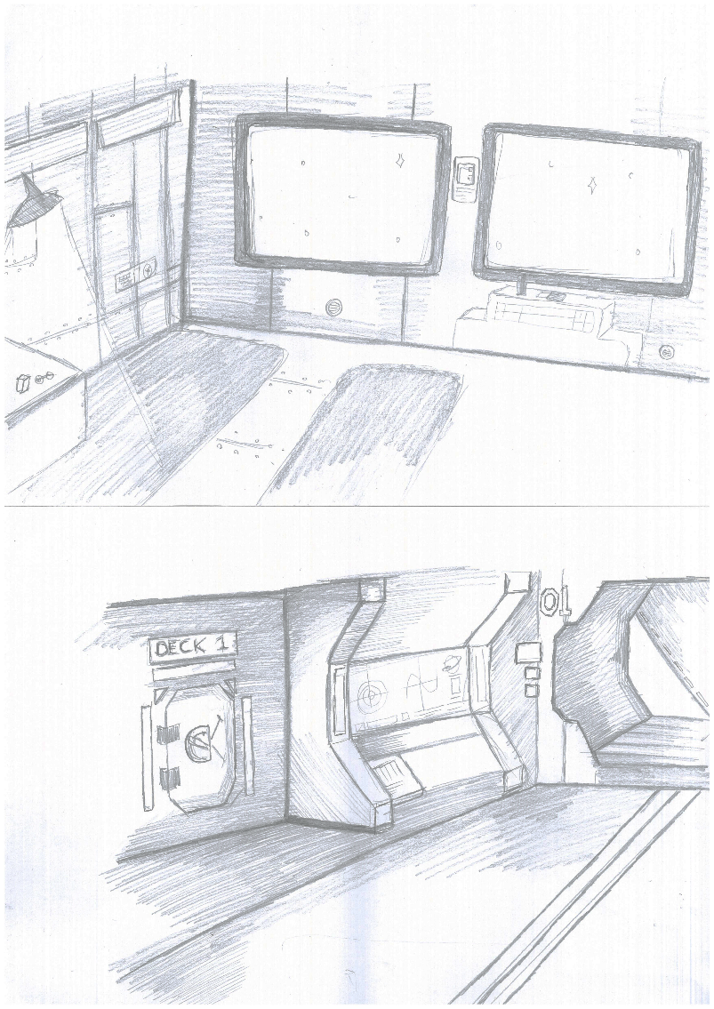

## Inspiration

